# 添加第三站点SQLDR

日期：2021/04/22

## 虚拟机硬件配置

|  |  |  |  |
| --- | --- | --- | --- |
| **描述** | **盘符** | **空间大小** | **VMware虚拟化磁盘文件位置** |
| 系统盘 | C: | 200GB | [HDS_2TB_192.168.10.71] HIS-SQLDR/HIS-SQLDR.vmdk |
| DATA | D: | 1024GB | [HDS_2TB_192.168.10.71] HIS-SQLDR/HIS-SQLDR_1.vmdk |
| LOG | E: | 400GB | [Local_192.168.10.71] HIS-SQLDR/HIS-SQLDR.vmdk |
| TempDB | Z: | 400GB | [Local_192.168.10.71] HIS-SQLDR/HIS-SQLDR_1.vmdk |

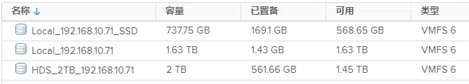

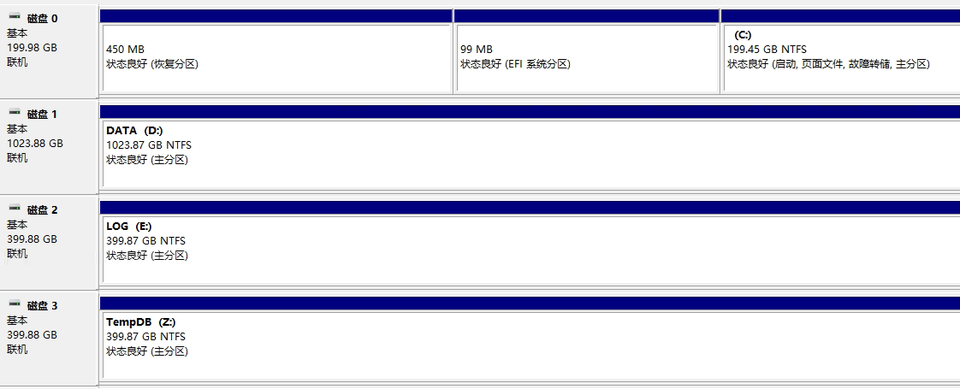

## 数据库路径

D:\HIS_DATA

D:\HIS_Log

D:\HIS_TempDB

D:\Backup

## IP地址配置：

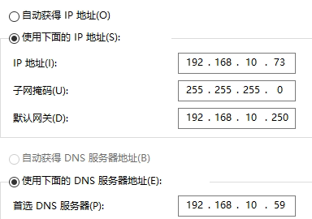

## SQLDR修改主机名，加入域控制器（192.168.10.59）

Rename-Computer -NewName SQLDR -Restart

Add-Computer -DomainName his.com -Restart

身份认证：[dcadmin@his.com](mailto:dcadmin@his.com)，密码：123zx,.

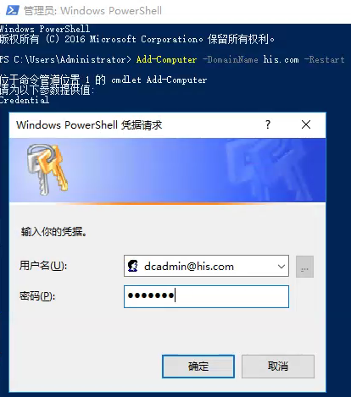

### 4.1、加入不了域控，可能因为防火墙端口限制：

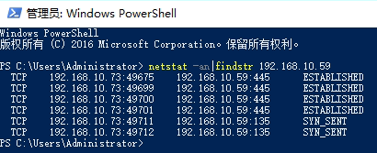

RPC：TCP: 135

SMB：TCP: 445

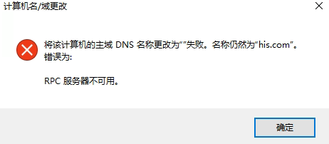

### 4.2、有关AD域控的服务端口：

**Active Directory and Active Directory Domain Services Port Requirements：**

<https://docs.microsoft.com/en-us/previous-versions/windows/it-pro/windows-server-2008-R2-and-2008/dd772723(v=ws.10)>

<https://social.technet.microsoft.com/Forums/zh-CN/2f9131ea-5d9f-4e12-9f05-17ef39c0babc/22495255112104622120368903680738450287792268123545228062145724?forum=winserver8zhcn>

服务器上的安全数据库没有此工作站信任关系的计算机账户



# 加入域控，需要开通访问AD服务器的TCP445端口

# 禁用TCP/IP上的NetBIOS

### 4.3、将dcadmin@his.com加入本地Administrator组中。

以administrator管理员身份登录SQLDR，将dcadmin@his.com加入本地Administrators组中。

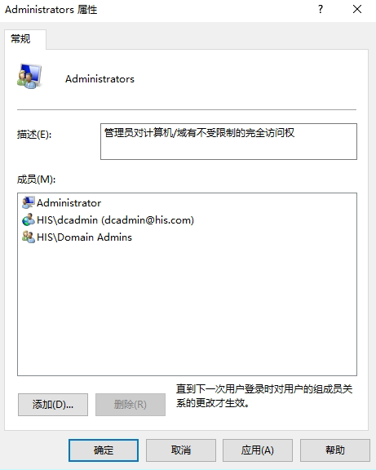

## 远程安装集群节点的windows组件：

### 5.1、安装.Net 3.0（可在AD域控上远程安装）

|  |
| --- |
| Install-WindowsFeature -Name Net-Framework-Core -source D:\sources\sxs -ComputerName SQLDR  Install-WindowsFeature -Name PowerShell-V2 -source D:\sources\sxs -ComputerName SQLDR  Get-WindowsFeature *Framework-Core* -ComputerName SQLDR |
| SQLDR上开放：TCP:5985 |

### 5.2、安装配置WSFC集群（在AD域控上远程安装）

|  |
| --- |
| Install-WindowsFeature -Name Failover-Clustering -IncludeManagementTools -ComputerName SQLDR  Get-WindowsFeature -Name "Failover-Clustering", "Telnet-Client" | Install-WindowsFeature -IncludeManagementTool -ComputerName SQLDR  Add-WindowsFeature -Name RSAT-Clustering-AutomationServer -ComputerName SQLDR  Add-WindowsFeature -Name RSAT-Clustering-CmdInterface -ComputerName SQLDR  Add-WindowsFeature -Name RSAT-Clustering-PowerShell -ComputerName SQLDR  Add-WindowsFeature -Name RSAT-Clustering-Mgmt -ComputerName SQLDR  Get-WindowsFeature *Cluster* -ComputerName SQLDR  get-windowsfeature Failover* -ComputerName SQLDR |
|  |

### 5.3、添加集群节点

|  |
| --- |
| Get-Cluster –Name cluster | Add-ClusterNode –Name SQLDR |

## 防火墙配置脚本：

|  |
| --- |
| netsh advfirewall firewall add rule name="SQL Server (TCP:1433)" dir=in localport=1433 protocol=TCP action=allow  netsh advfirewall firewall add rule name="SQL Admin Connect (TCP:1434)" dir=in localport=1434 protocol=TCP action=allow  netsh advfirewall firewall add rule name="SQL Browser (UDP:1434)" dir=in localport=1434 protocol=UDP action=allow  netsh advfirewall firewall add rule name="SQL Debugger/RPC(TCP:135)" dir=in localport=135 protocol=TCP action=allow  netsh advfirewall firewall add rule name="SQL Always On (TCP:5022)" dir=in localport=5022 protocol=TCP action=allow  netsh advfirewall firewall add rule name="SQL Service Broker (TCP:4022)" dir=in localport=5022 protocol=TCP action=allow  netsh advfirewall firewall add rule name="Medical File Service （TCP:6234）" dir=in localport=6234 protocol=TCP action=allow  netsh advfirewall firewall add rule name="SNMP(UDP:161)" dir=in localport=161 protocol=UDP action=allow  netsh advfirewall firewall add rule name="Iperf Inbound Port 5001~5099" dir=in localport=5001-5099 protocol=TCP action=allow  netsh advfirewall firewall add rule name="Cluster Communication" dir=in action=allow enable=yes remoteip=192.168.10.56-192.168.10.60,192.168.10.73,192.168.10.74  netsh advfirewall set allprofiles state on  netsh firewall set logging %systemroot%system32LogFilesFirewallpfirewall.log 32767 ENABLE |
|  |

## 安装SQL2014与SP3

### 7.1、查询新盘，使其联机并且初始化：

|  |
| --- |
| Get-Disk  Get-Disk | Where-Object { $_.FriendlyName -like " VMware*" }  Set-Disk -Number 1 -IsOffline $false  Set-Disk -Number 2 -IsOffline $false  Set-Disk -Number 3 -IsOffline $false  Initialize-Disk -Number 1  Initialize-Disk -Number 2  Initialize-Disk -Number 3  Set-Disk -Number 4 -IsOffline $true  Set-Disk -Number 5 -IsOffline $true  the System data files (master, model, msdb) and tempdb. |

### 7.2、安装SQL Server 2014：

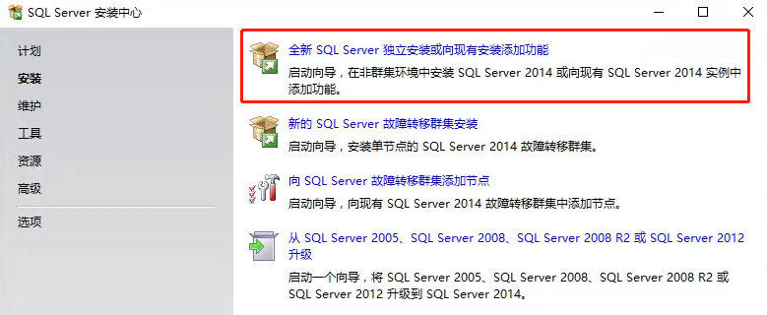

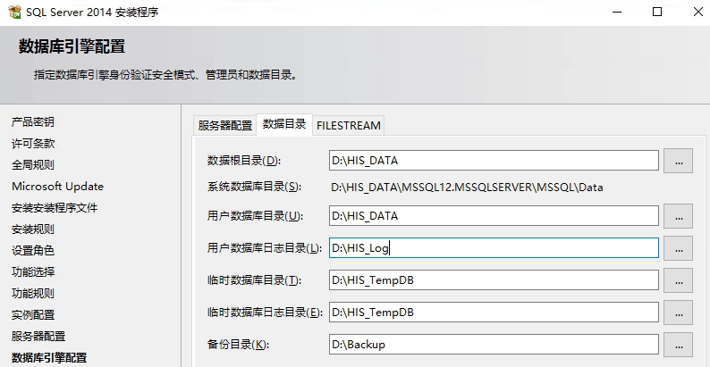

D:\HIS_DATA

D:\HIS_Log

D:\HIS_TempDB

D:\Backup

### 7.3、接着安装SP3、SSMS



## 配置并启用AlwaysOn

### 8.1、启用SQLDR上的AlwaysOn

打开SQLServer2014管理配置器，配置如下

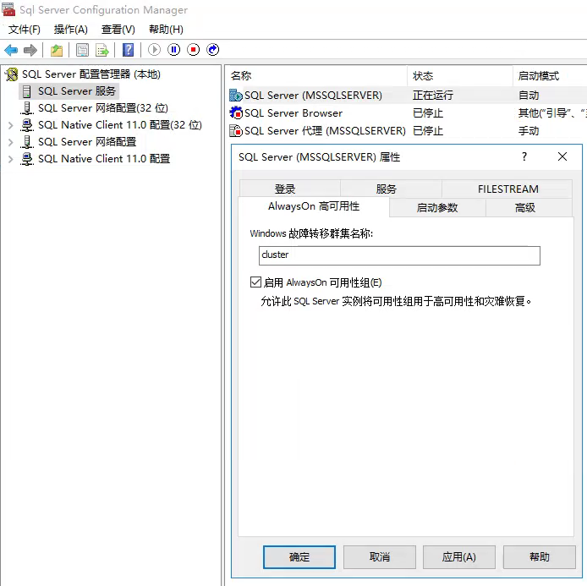

修改SQLServer实例启动账户为HIS\dcadmin： 123zx,.

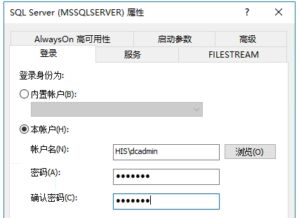

会要求重启服务，重启即可。

重启后，确认服务属性，

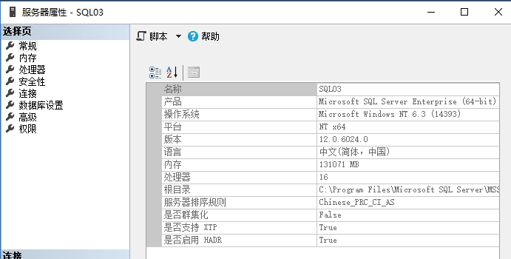

### 8.2、添加副本：SQLDR

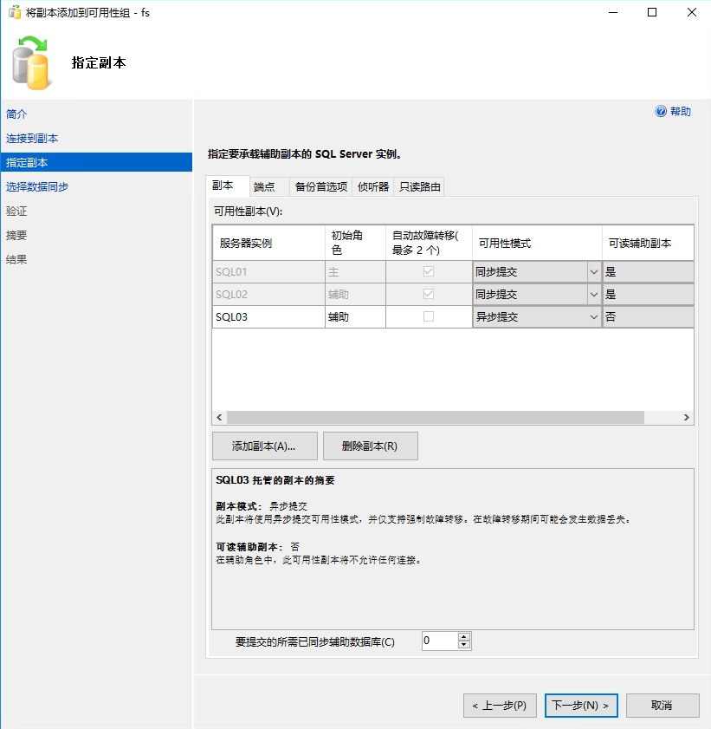

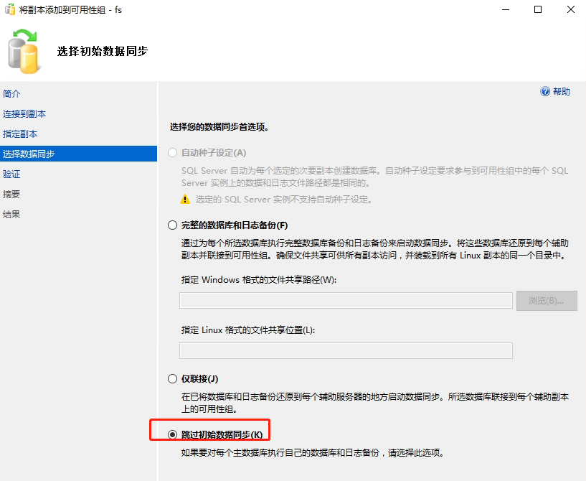

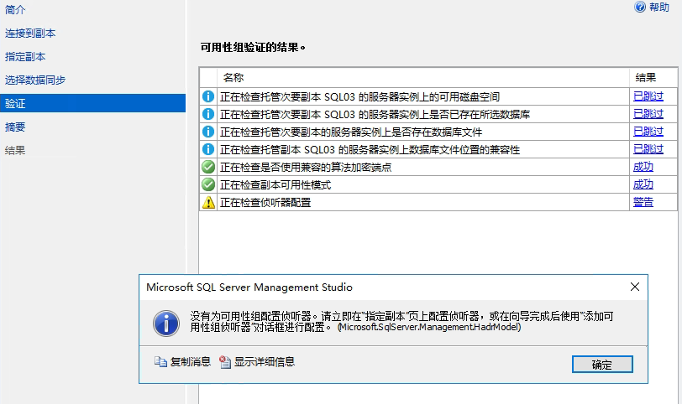

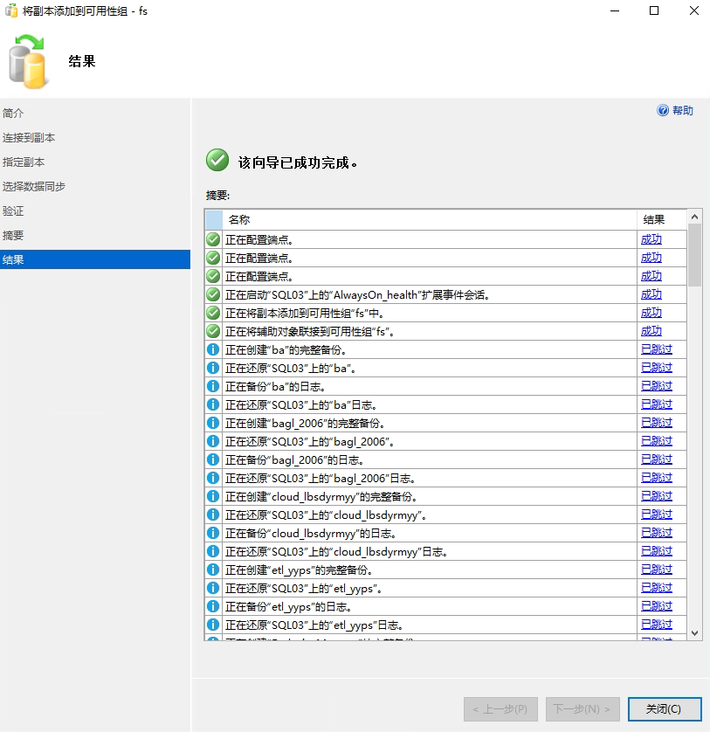

## 跑一下流程：还原1个测试库（test）

### 9.1、还原一个测试库dr_test

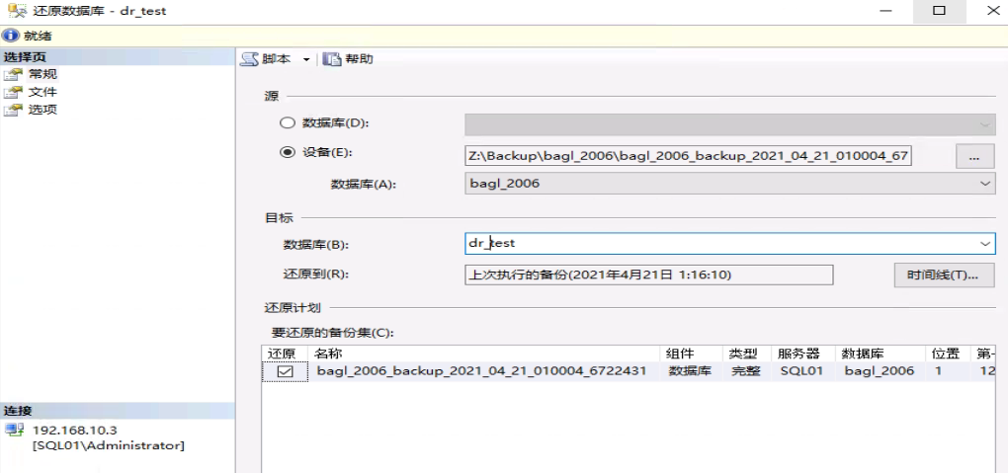

|  |
| --- |
| USE [master]  RESTORE DATABASE [dr_test] FROM DISK = N'Z:\Backup\bagl_2006\bagl_2006_backup_2021_04_21_010004_6722431.bak' WITH FILE = 1, MOVE N'bagl_2006_Data' TO N'D:\HIS_DATA\dr_test.mdf', MOVE N'bagl_2006_Log' TO N'E:\HIS_Log\dr_test_1.ldf', NOUNLOAD, STATS = 5  GO |

### 9.2、将测试库dr_test添加到可用性组中：

BACKUP DATABASE [dr_test] TO DISK = N'E:\AG_Backup\dr_test' WITH NOFORMAT, NOINIT, NAME = N'dr_test-完整 数据库 备份', SKIP, NOREWIND, NOUNLOAD, STATS = 10

GO

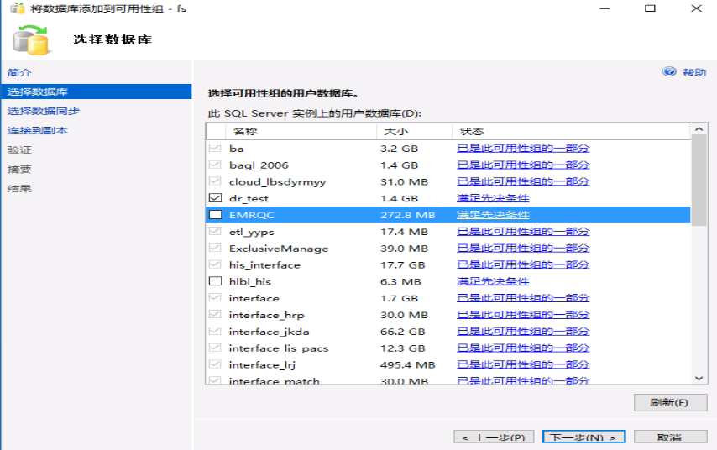

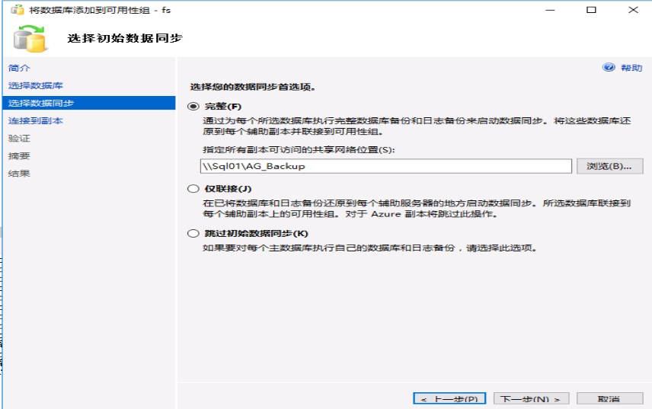

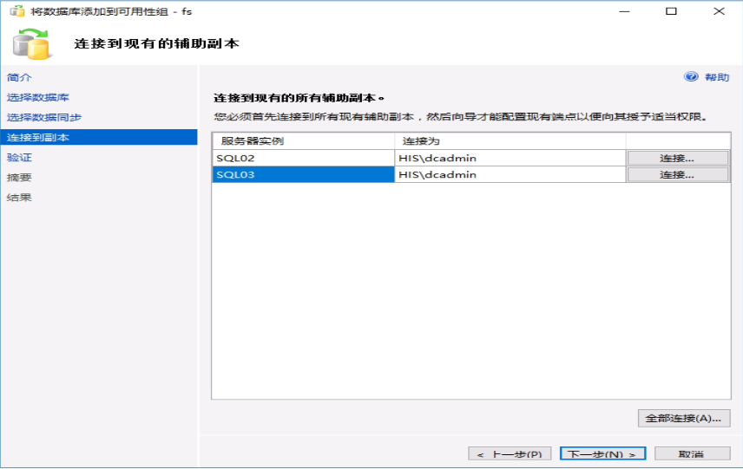

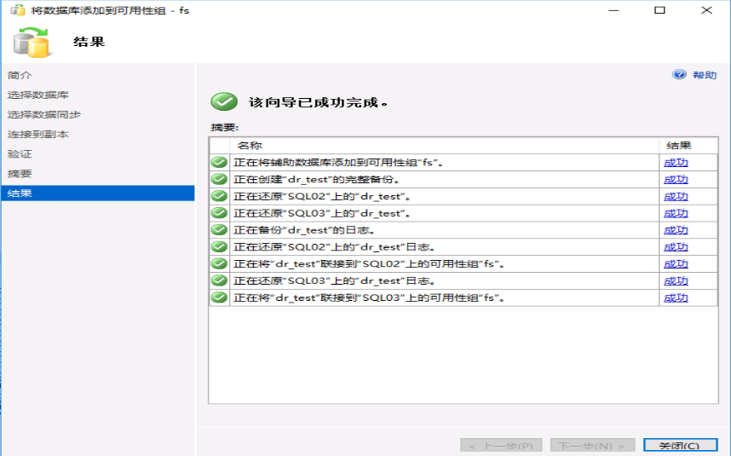

## 正式部署SQLDR的数据库

老服务器做的HIS镜像，库要全。

打虚拟资源池做个HIS镜像，以后当10.27用。只要zy、mz、jc、ba和所有interface开头的库就行

### 10.1、自动生成备份脚本，在SQL01上做备份

|  |
| --- |
| #coding:utf-8  import pymssql  # 连接SQL SERVER服务器  host, user, password, database = '192.168.10.56', 'HIS\dcadmin', '123zx,.', 'master'  conn = pymssql.connect(host, user, password, database) #获取连接  cursor = conn.cursor() # 获取光标  # 获取系统数据库的集合  # sql = "select count(*) from uh_portal_system_version_info"  # sql = "select @@version"  # sql = "select * from master.sys.availability_replicas"  sql = "select name from sysdatabases"  cursor.execute(sql)  row = cursor.fetchall()  db_set = set()  for i in row:  db_set.add(i[0])  sys_db = {'master', 'tempdb', 'model', 'msdb', 'distribution'}  db_set = db_set - sys_db  db_list = list(db_set)  db_list.sort()  print(len(db_list), '\n\n', str(db_list), '\n\n')  # NO_COMPRESSION COMPRESSION  backup = """-- %num、备份数据库：%s  USE %s;  GO  BACKUP DATABASE %s  TO DISK = 'E:\AG_Backup\%s.Bak'  WITH FORMAT, NO_COMPRESSION,  NAME = 'Full Backup of %s';  GO  BACKUP LOG %s  TO DISK = 'E:\AG_Backup\%s_TLOG.Bak'  WITH FORMAT, NO_COMPRESSION,  NAME = 'TLOG Backup of %s';  GO  """  sql = ''  for n, i in enumerate(db_list, start=1):  sql += backup.replace('%s', i).replace('%num', str(n))  print(sql) |
| 38  ['EMRQC', 'ExclusiveManage', 'NSHIS_WLPT', 'NSHIS_YYPT', 'XHIS_interface', 'YDYL', 'ba', 'bagl_2006', 'cloud_lbsdyrmyy', 'dr_test', 'etl_yyps', 'his_interface', 'hlbl_his', 'interface', 'interface_Ychz', 'interface_hrp', 'interface_jkda', 'interface_lis_pacs', 'interface_lrj', 'interface_match', 'interface_quyiwang', 'interface_yyps', 'jc', 'jc_bz', 'jjhs', 'jkda_interface', 'ldcx', 'mz', 'pw', 'rs', 'sbgl', 'sjbf', 'xtwh', 'yj', 'ys', 'yw', 'zy', 'zy_dzbl_zhshk']  -- 1、备份数据库：EMRQC  USE EMRQC;  GO  BACKUP DATABASE EMRQC  TO DISK = 'E:\AG_Backup\EMRQC.Bak'  WITH FORMAT, NO_COMPRESSION,  NAME = 'Full Backup of EMRQC';  GO  BACKUP LOG EMRQC  TO DISK = 'E:\AG_Backup\EMRQC_TLOG.Bak'  WITH FORMAT, NO_COMPRESSION,  NAME = 'TLOG Backup of EMRQC';  GO  -- 2、备份数据库：ExclusiveManage  USE ExclusiveManage;  GO  BACKUP DATABASE ExclusiveManage  TO DISK = 'E:\AG_Backup\ExclusiveManage.Bak'  WITH FORMAT, NO_COMPRESSION,  NAME = 'Full Backup of ExclusiveManage';  GO  BACKUP LOG ExclusiveManage  TO DISK = 'E:\AG_Backup\ExclusiveManage_TLOG.Bak'  WITH FORMAT, NO_COMPRESSION,  NAME = 'TLOG Backup of ExclusiveManage';  GO  -- 3、备份数据库：NSHIS_WLPT  USE NSHIS_WLPT;  GO  BACKUP DATABASE NSHIS_WLPT  TO DISK = 'E:\AG_Backup\NSHIS_WLPT.Bak'  WITH FORMAT, NO_COMPRESSION,  NAME = 'Full Backup of NSHIS_WLPT';  GO  BACKUP LOG NSHIS_WLPT  TO DISK = 'E:\AG_Backup\NSHIS_WLPT_TLOG.Bak'  WITH FORMAT, NO_COMPRESSION,  NAME = 'TLOG Backup of NSHIS_WLPT';  GO  -- 4、备份数据库：NSHIS_YYPT  USE NSHIS_YYPT;  GO  BACKUP DATABASE NSHIS_YYPT  TO DISK = 'E:\AG_Backup\NSHIS_YYPT.Bak'  WITH FORMAT, NO_COMPRESSION,  NAME = 'Full Backup of NSHIS_YYPT';  GO  BACKUP LOG NSHIS_YYPT  TO DISK = 'E:\AG_Backup\NSHIS_YYPT_TLOG.Bak'  WITH FORMAT, NO_COMPRESSION,  NAME = 'TLOG Backup of NSHIS_YYPT';  GO  -- 5、备份数据库：XHIS_interface  USE XHIS_interface;  GO  BACKUP DATABASE XHIS_interface  TO DISK = 'E:\AG_Backup\XHIS_interface.Bak'  WITH FORMAT, NO_COMPRESSION,  NAME = 'Full Backup of XHIS_interface';  GO  BACKUP LOG XHIS_interface  TO DISK = 'E:\AG_Backup\XHIS_interface_TLOG.Bak'  WITH FORMAT, NO_COMPRESSION,  NAME = 'TLOG Backup of XHIS_interface';  GO  -- 6、备份数据库：YDYL  USE YDYL;  GO  BACKUP DATABASE YDYL  TO DISK = 'E:\AG_Backup\YDYL.Bak'  WITH FORMAT, NO_COMPRESSION,  NAME = 'Full Backup of YDYL';  GO  BACKUP LOG YDYL  TO DISK = 'E:\AG_Backup\YDYL_TLOG.Bak'  WITH FORMAT, NO_COMPRESSION,  NAME = 'TLOG Backup of YDYL';  GO  -- 7、备份数据库：ba  USE ba;  GO  BACKUP DATABASE ba  TO DISK = 'E:\AG_Backup\ba.Bak'  WITH FORMAT, NO_COMPRESSION,  NAME = 'Full Backup of ba';  GO  BACKUP LOG ba  TO DISK = 'E:\AG_Backup\ba_TLOG.Bak'  WITH FORMAT, NO_COMPRESSION,  NAME = 'TLOG Backup of ba';  GO  -- 8、备份数据库：bagl_2006  USE bagl_2006;  GO  BACKUP DATABASE bagl_2006  TO DISK = 'E:\AG_Backup\bagl_2006.Bak'  WITH FORMAT, NO_COMPRESSION,  NAME = 'Full Backup of bagl_2006';  GO  BACKUP LOG bagl_2006  TO DISK = 'E:\AG_Backup\bagl_2006_TLOG.Bak'  WITH FORMAT, NO_COMPRESSION,  NAME = 'TLOG Backup of bagl_2006';  GO  -- 9、备份数据库：cloud_lbsdyrmyy  USE cloud_lbsdyrmyy;  GO  BACKUP DATABASE cloud_lbsdyrmyy  TO DISK = 'E:\AG_Backup\cloud_lbsdyrmyy.Bak'  WITH FORMAT, NO_COMPRESSION,  NAME = 'Full Backup of cloud_lbsdyrmyy';  GO  BACKUP LOG cloud_lbsdyrmyy  TO DISK = 'E:\AG_Backup\cloud_lbsdyrmyy_TLOG.Bak'  WITH FORMAT, NO_COMPRESSION,  NAME = 'TLOG Backup of cloud_lbsdyrmyy';  GO  -- 10、备份数据库：dr_test  USE dr_test;  GO  BACKUP DATABASE dr_test  TO DISK = 'E:\AG_Backup\dr_test.Bak'  WITH FORMAT, NO_COMPRESSION,  NAME = 'Full Backup of dr_test';  GO  BACKUP LOG dr_test  TO DISK = 'E:\AG_Backup\dr_test_TLOG.Bak'  WITH FORMAT, NO_COMPRESSION,  NAME = 'TLOG Backup of dr_test';  GO  -- 11、备份数据库：etl_yyps  USE etl_yyps;  GO  BACKUP DATABASE etl_yyps  TO DISK = 'E:\AG_Backup\etl_yyps.Bak'  WITH FORMAT, NO_COMPRESSION,  NAME = 'Full Backup of etl_yyps';  GO  BACKUP LOG etl_yyps  TO DISK = 'E:\AG_Backup\etl_yyps_TLOG.Bak'  WITH FORMAT, NO_COMPRESSION,  NAME = 'TLOG Backup of etl_yyps';  GO  -- 12、备份数据库：his_interface  USE his_interface;  GO  BACKUP DATABASE his_interface  TO DISK = 'E:\AG_Backup\his_interface.Bak'  WITH FORMAT, NO_COMPRESSION,  NAME = 'Full Backup of his_interface';  GO  BACKUP LOG his_interface  TO DISK = 'E:\AG_Backup\his_interface_TLOG.Bak'  WITH FORMAT, NO_COMPRESSION,  NAME = 'TLOG Backup of his_interface';  GO  -- 13、备份数据库：hlbl_his  USE hlbl_his;  GO  BACKUP DATABASE hlbl_his  TO DISK = 'E:\AG_Backup\hlbl_his.Bak'  WITH FORMAT, NO_COMPRESSION,  NAME = 'Full Backup of hlbl_his';  GO  BACKUP LOG hlbl_his  TO DISK = 'E:\AG_Backup\hlbl_his_TLOG.Bak'  WITH FORMAT, NO_COMPRESSION,  NAME = 'TLOG Backup of hlbl_his';  GO  -- 14、备份数据库：interface  USE interface;  GO  BACKUP DATABASE interface  TO DISK = 'E:\AG_Backup\interface.Bak'  WITH FORMAT, NO_COMPRESSION,  NAME = 'Full Backup of interface';  GO  BACKUP LOG interface  TO DISK = 'E:\AG_Backup\interface_TLOG.Bak'  WITH FORMAT, NO_COMPRESSION,  NAME = 'TLOG Backup of interface';  GO  -- 15、备份数据库：interface_Ychz  USE interface_Ychz;  GO  BACKUP DATABASE interface_Ychz  TO DISK = 'E:\AG_Backup\interface_Ychz.Bak'  WITH FORMAT, NO_COMPRESSION,  NAME = 'Full Backup of interface_Ychz';  GO  BACKUP LOG interface_Ychz  TO DISK = 'E:\AG_Backup\interface_Ychz_TLOG.Bak'  WITH FORMAT, NO_COMPRESSION,  NAME = 'TLOG Backup of interface_Ychz';  GO  -- 16、备份数据库：interface_hrp  USE interface_hrp;  GO  BACKUP DATABASE interface_hrp  TO DISK = 'E:\AG_Backup\interface_hrp.Bak'  WITH FORMAT, NO_COMPRESSION,  NAME = 'Full Backup of interface_hrp';  GO  BACKUP LOG interface_hrp  TO DISK = 'E:\AG_Backup\interface_hrp_TLOG.Bak'  WITH FORMAT, NO_COMPRESSION,  NAME = 'TLOG Backup of interface_hrp';  GO  -- 17、备份数据库：interface_jkda  USE interface_jkda;  GO  BACKUP DATABASE interface_jkda  TO DISK = 'E:\AG_Backup\interface_jkda.Bak'  WITH FORMAT, NO_COMPRESSION,  NAME = 'Full Backup of interface_jkda';  GO  BACKUP LOG interface_jkda  TO DISK = 'E:\AG_Backup\interface_jkda_TLOG.Bak'  WITH FORMAT, NO_COMPRESSION,  NAME = 'TLOG Backup of interface_jkda';  GO  -- 18、备份数据库：interface_lis_pacs  USE interface_lis_pacs;  GO  BACKUP DATABASE interface_lis_pacs  TO DISK = 'E:\AG_Backup\interface_lis_pacs.Bak'  WITH FORMAT, NO_COMPRESSION,  NAME = 'Full Backup of interface_lis_pacs';  GO  BACKUP LOG interface_lis_pacs  TO DISK = 'E:\AG_Backup\interface_lis_pacs_TLOG.Bak'  WITH FORMAT, NO_COMPRESSION,  NAME = 'TLOG Backup of interface_lis_pacs';  GO  -- 19、备份数据库：interface_lrj  USE interface_lrj;  GO  BACKUP DATABASE interface_lrj  TO DISK = 'E:\AG_Backup\interface_lrj.Bak'  WITH FORMAT, NO_COMPRESSION,  NAME = 'Full Backup of interface_lrj';  GO  BACKUP LOG interface_lrj  TO DISK = 'E:\AG_Backup\interface_lrj_TLOG.Bak'  WITH FORMAT, NO_COMPRESSION,  NAME = 'TLOG Backup of interface_lrj';  GO  -- 20、备份数据库：interface_match  USE interface_match;  GO  BACKUP DATABASE interface_match  TO DISK = 'E:\AG_Backup\interface_match.Bak'  WITH FORMAT, NO_COMPRESSION,  NAME = 'Full Backup of interface_match';  GO  BACKUP LOG interface_match  TO DISK = 'E:\AG_Backup\interface_match_TLOG.Bak'  WITH FORMAT, NO_COMPRESSION,  NAME = 'TLOG Backup of interface_match';  GO  -- 21、备份数据库：interface_quyiwang  USE interface_quyiwang;  GO  BACKUP DATABASE interface_quyiwang  TO DISK = 'E:\AG_Backup\interface_quyiwang.Bak'  WITH FORMAT, NO_COMPRESSION,  NAME = 'Full Backup of interface_quyiwang';  GO  BACKUP LOG interface_quyiwang  TO DISK = 'E:\AG_Backup\interface_quyiwang_TLOG.Bak'  WITH FORMAT, NO_COMPRESSION,  NAME = 'TLOG Backup of interface_quyiwang';  GO  -- 22、备份数据库：interface_yyps  USE interface_yyps;  GO  BACKUP DATABASE interface_yyps  TO DISK = 'E:\AG_Backup\interface_yyps.Bak'  WITH FORMAT, NO_COMPRESSION,  NAME = 'Full Backup of interface_yyps';  GO  BACKUP LOG interface_yyps  TO DISK = 'E:\AG_Backup\interface_yyps_TLOG.Bak'  WITH FORMAT, NO_COMPRESSION,  NAME = 'TLOG Backup of interface_yyps';  GO  -- 23、备份数据库：jc  USE jc;  GO  BACKUP DATABASE jc  TO DISK = 'E:\AG_Backup\jc.Bak'  WITH FORMAT, NO_COMPRESSION,  NAME = 'Full Backup of jc';  GO  BACKUP LOG jc  TO DISK = 'E:\AG_Backup\jc_TLOG.Bak'  WITH FORMAT, NO_COMPRESSION,  NAME = 'TLOG Backup of jc';  GO  -- 24、备份数据库：jc_bz  USE jc_bz;  GO  BACKUP DATABASE jc_bz  TO DISK = 'E:\AG_Backup\jc_bz.Bak'  WITH FORMAT, NO_COMPRESSION,  NAME = 'Full Backup of jc_bz';  GO  BACKUP LOG jc_bz  TO DISK = 'E:\AG_Backup\jc_bz_TLOG.Bak'  WITH FORMAT, NO_COMPRESSION,  NAME = 'TLOG Backup of jc_bz';  GO  -- 25、备份数据库：jjhs  USE jjhs;  GO  BACKUP DATABASE jjhs  TO DISK = 'E:\AG_Backup\jjhs.Bak'  WITH FORMAT, NO_COMPRESSION,  NAME = 'Full Backup of jjhs';  GO  BACKUP LOG jjhs  TO DISK = 'E:\AG_Backup\jjhs_TLOG.Bak'  WITH FORMAT, NO_COMPRESSION,  NAME = 'TLOG Backup of jjhs';  GO  -- 26、备份数据库：jkda_interface  USE jkda_interface;  GO  BACKUP DATABASE jkda_interface  TO DISK = 'E:\AG_Backup\jkda_interface.Bak'  WITH FORMAT, NO_COMPRESSION,  NAME = 'Full Backup of jkda_interface';  GO  BACKUP LOG jkda_interface  TO DISK = 'E:\AG_Backup\jkda_interface_TLOG.Bak'  WITH FORMAT, NO_COMPRESSION,  NAME = 'TLOG Backup of jkda_interface';  GO  -- 27、备份数据库：ldcx  USE ldcx;  GO  BACKUP DATABASE ldcx  TO DISK = 'E:\AG_Backup\ldcx.Bak'  WITH FORMAT, NO_COMPRESSION,  NAME = 'Full Backup of ldcx';  GO  BACKUP LOG ldcx  TO DISK = 'E:\AG_Backup\ldcx_TLOG.Bak'  WITH FORMAT, NO_COMPRESSION,  NAME = 'TLOG Backup of ldcx';  GO  -- 28、备份数据库：mz  USE mz;  GO  BACKUP DATABASE mz  TO DISK = 'E:\AG_Backup\mz.Bak'  WITH FORMAT, NO_COMPRESSION,  NAME = 'Full Backup of mz';  GO  BACKUP LOG mz  TO DISK = 'E:\AG_Backup\mz_TLOG.Bak'  WITH FORMAT, NO_COMPRESSION,  NAME = 'TLOG Backup of mz';  GO  -- 29、备份数据库：pw  USE pw;  GO  BACKUP DATABASE pw  TO DISK = 'E:\AG_Backup\pw.Bak'  WITH FORMAT, NO_COMPRESSION,  NAME = 'Full Backup of pw';  GO  BACKUP LOG pw  TO DISK = 'E:\AG_Backup\pw_TLOG.Bak'  WITH FORMAT, NO_COMPRESSION,  NAME = 'TLOG Backup of pw';  GO  -- 30、备份数据库：rs  USE rs;  GO  BACKUP DATABASE rs  TO DISK = 'E:\AG_Backup\rs.Bak'  WITH FORMAT, NO_COMPRESSION,  NAME = 'Full Backup of rs';  GO  BACKUP LOG rs  TO DISK = 'E:\AG_Backup\rs_TLOG.Bak'  WITH FORMAT, NO_COMPRESSION,  NAME = 'TLOG Backup of rs';  GO  -- 31、备份数据库：sbgl  USE sbgl;  GO  BACKUP DATABASE sbgl  TO DISK = 'E:\AG_Backup\sbgl.Bak'  WITH FORMAT, NO_COMPRESSION,  NAME = 'Full Backup of sbgl';  GO  BACKUP LOG sbgl  TO DISK = 'E:\AG_Backup\sbgl_TLOG.Bak'  WITH FORMAT, NO_COMPRESSION,  NAME = 'TLOG Backup of sbgl';  GO  -- 32、备份数据库：sjbf  USE sjbf;  GO  BACKUP DATABASE sjbf  TO DISK = 'E:\AG_Backup\sjbf.Bak'  WITH FORMAT, NO_COMPRESSION,  NAME = 'Full Backup of sjbf';  GO  BACKUP LOG sjbf  TO DISK = 'E:\AG_Backup\sjbf_TLOG.Bak'  WITH FORMAT, NO_COMPRESSION,  NAME = 'TLOG Backup of sjbf';  GO  -- 33、备份数据库：xtwh  USE xtwh;  GO  BACKUP DATABASE xtwh  TO DISK = 'E:\AG_Backup\xtwh.Bak'  WITH FORMAT, NO_COMPRESSION,  NAME = 'Full Backup of xtwh';  GO  BACKUP LOG xtwh  TO DISK = 'E:\AG_Backup\xtwh_TLOG.Bak'  WITH FORMAT, NO_COMPRESSION,  NAME = 'TLOG Backup of xtwh';  GO  -- 34、备份数据库：yj  USE yj;  GO  BACKUP DATABASE yj  TO DISK = 'E:\AG_Backup\yj.Bak'  WITH FORMAT, NO_COMPRESSION,  NAME = 'Full Backup of yj';  GO  BACKUP LOG yj  TO DISK = 'E:\AG_Backup\yj_TLOG.Bak'  WITH FORMAT, NO_COMPRESSION,  NAME = 'TLOG Backup of yj';  GO  -- 35、备份数据库：ys  USE ys;  GO  BACKUP DATABASE ys  TO DISK = 'E:\AG_Backup\ys.Bak'  WITH FORMAT, NO_COMPRESSION,  NAME = 'Full Backup of ys';  GO  BACKUP LOG ys  TO DISK = 'E:\AG_Backup\ys_TLOG.Bak'  WITH FORMAT, NO_COMPRESSION,  NAME = 'TLOG Backup of ys';  GO  -- 36、备份数据库：yw  USE yw;  GO  BACKUP DATABASE yw  TO DISK = 'E:\AG_Backup\yw.Bak'  WITH FORMAT, NO_COMPRESSION,  NAME = 'Full Backup of yw';  GO  BACKUP LOG yw  TO DISK = 'E:\AG_Backup\yw_TLOG.Bak'  WITH FORMAT, NO_COMPRESSION,  NAME = 'TLOG Backup of yw';  GO  -- 37、备份数据库：zy  USE zy;  GO  BACKUP DATABASE zy  TO DISK = 'E:\AG_Backup\zy.Bak'  WITH FORMAT, NO_COMPRESSION,  NAME = 'Full Backup of zy';  GO  BACKUP LOG zy  TO DISK = 'E:\AG_Backup\zy_TLOG.Bak'  WITH FORMAT, NO_COMPRESSION,  NAME = 'TLOG Backup of zy';  GO  -- 38、备份数据库：zy_dzbl_zhshk  USE zy_dzbl_zhshk;  GO  BACKUP DATABASE zy_dzbl_zhshk  TO DISK = 'E:\AG_Backup\zy_dzbl_zhshk.Bak'  WITH FORMAT, NO_COMPRESSION,  NAME = 'Full Backup of zy_dzbl_zhshk';  GO  BACKUP LOG zy_dzbl_zhshk  TO DISK = 'E:\AG_Backup\zy_dzbl_zhshk_TLOG.Bak'  WITH FORMAT, NO_COMPRESSION,  NAME = 'TLOG Backup of zy_dzbl_zhshk';  GO |



不压缩备份耗时：22分钟（BAK文件总大小：136GB）

### 10.2、在SQLDR上自动生成还原脚本

|  |
| --- |
| #coding:utf-8  import pymssql  # 连接SQL SERVER服务器  host, user, password, database = '192.168.10.56', 'HIS\dcadmin', '123zx,.', 'master'  conn = pymssql.connect(host, user, password, database) #获取连接  cursor = conn.cursor() # 获取光标  # 获取系统数据库的集合  # sql = "select count(*) from uh_portal_system_version_info"  # sql = "select @@version"  # sql = "select * from master.sys.availability_replicas"  sql = "select name from sysdatabases"  cursor.execute(sql)  row = cursor.fetchall()  db_set = set()  for i in row:  db_set.add(i[0])  sys_db = {'master', 'tempdb', 'model', 'msdb', 'distribution'}  db_set = db_set - sys_db  db_list = list(db_set)  db_list.sort()  restore = """  -- %num、恢复数据库：%s  RESTORE DATABASE [%s]  FROM DISK = N'\\\\SQL01\AG_Backup\%s.Bak' WITH  NORECOVERY,  NOUNLOAD,  STATS = 5  GO  RESTORE LOG [%s]  FROM DISK = N'\\\\SQL01\AG_Backup\%s_TLOG.Bak' WITH  NORECOVERY,  NOUNLOAD,  STATS = 10  GO  """  sql = """USE [master]  """  for n, i in enumerate(db_list, start=1):  sql += restore.replace('%s', i).replace('%num', str(n))  print(sql) |
| USE [master]  -- 1、恢复数据库：EMRQC  RESTORE DATABASE [EMRQC]  FROM DISK = N'\\SQL01\AG_Backup\EMRQC.Bak' WITH  NORECOVERY,  NOUNLOAD,  STATS = 5  GO  RESTORE LOG [EMRQC]  FROM DISK = N'\\SQL01\AG_Backup\EMRQC_TLOG.Bak' WITH  NORECOVERY,  NOUNLOAD,  STATS = 10  GO  -- 2、恢复数据库：ExclusiveManage  RESTORE DATABASE [ExclusiveManage]  FROM DISK = N'\\SQL01\AG_Backup\ExclusiveManage.Bak' WITH  NORECOVERY,  NOUNLOAD,  STATS = 5  GO  RESTORE LOG [ExclusiveManage]  FROM DISK = N'\\SQL01\AG_Backup\ExclusiveManage_TLOG.Bak' WITH  NORECOVERY,  NOUNLOAD,  STATS = 10  GO  -- 3、恢复数据库：NSHIS_WLPT  RESTORE DATABASE [NSHIS_WLPT]  FROM DISK = N'\\SQL01\AG_Backup\NSHIS_WLPT.Bak' WITH  NORECOVERY,  NOUNLOAD,  STATS = 5  GO  RESTORE LOG [NSHIS_WLPT]  FROM DISK = N'\\SQL01\AG_Backup\NSHIS_WLPT_TLOG.Bak' WITH  NORECOVERY,  NOUNLOAD,  STATS = 10  GO  -- 4、恢复数据库：NSHIS_YYPT  RESTORE DATABASE [NSHIS_YYPT]  FROM DISK = N'\\SQL01\AG_Backup\NSHIS_YYPT.Bak' WITH  NORECOVERY,  NOUNLOAD,  STATS = 5  GO  RESTORE LOG [NSHIS_YYPT]  FROM DISK = N'\\SQL01\AG_Backup\NSHIS_YYPT_TLOG.Bak' WITH  NORECOVERY,  NOUNLOAD,  STATS = 10  GO  -- 5、恢复数据库：XHIS_interface  RESTORE DATABASE [XHIS_interface]  FROM DISK = N'\\SQL01\AG_Backup\XHIS_interface.Bak' WITH  NORECOVERY,  NOUNLOAD,  STATS = 5  GO  RESTORE LOG [XHIS_interface]  FROM DISK = N'\\SQL01\AG_Backup\XHIS_interface_TLOG.Bak' WITH  NORECOVERY,  NOUNLOAD,  STATS = 10  GO  -- 6、恢复数据库：YDYL  RESTORE DATABASE [YDYL]  FROM DISK = N'\\SQL01\AG_Backup\YDYL.Bak' WITH  NORECOVERY,  NOUNLOAD,  STATS = 5  GO  RESTORE LOG [YDYL]  FROM DISK = N'\\SQL01\AG_Backup\YDYL_TLOG.Bak' WITH  NORECOVERY,  NOUNLOAD,  STATS = 10  GO  -- 7、恢复数据库：ba  RESTORE DATABASE [ba]  FROM DISK = N'\\SQL01\AG_Backup\ba.Bak' WITH  NORECOVERY,  NOUNLOAD,  STATS = 5  GO  RESTORE LOG [ba]  FROM DISK = N'\\SQL01\AG_Backup\ba_TLOG.Bak' WITH  NORECOVERY,  NOUNLOAD,  STATS = 10  GO  -- 8、恢复数据库：bagl_2006  RESTORE DATABASE [bagl_2006]  FROM DISK = N'\\SQL01\AG_Backup\bagl_2006.Bak' WITH  NORECOVERY,  NOUNLOAD,  STATS = 5  GO  RESTORE LOG [bagl_2006]  FROM DISK = N'\\SQL01\AG_Backup\bagl_2006_TLOG.Bak' WITH  NORECOVERY,  NOUNLOAD,  STATS = 10  GO  -- 9、恢复数据库：cloud_lbsdyrmyy  RESTORE DATABASE [cloud_lbsdyrmyy]  FROM DISK = N'\\SQL01\AG_Backup\cloud_lbsdyrmyy.Bak' WITH  NORECOVERY,  NOUNLOAD,  STATS = 5  GO  RESTORE LOG [cloud_lbsdyrmyy]  FROM DISK = N'\\SQL01\AG_Backup\cloud_lbsdyrmyy_TLOG.Bak' WITH  NORECOVERY,  NOUNLOAD,  STATS = 10  GO  -- 11、恢复数据库：etl_yyps  RESTORE DATABASE [etl_yyps]  FROM DISK = N'\\SQL01\AG_Backup\etl_yyps.Bak' WITH  NORECOVERY,  NOUNLOAD,  STATS = 5  GO  RESTORE LOG [etl_yyps]  FROM DISK = N'\\SQL01\AG_Backup\etl_yyps_TLOG.Bak' WITH  NORECOVERY,  NOUNLOAD,  STATS = 10  GO  -- 12、恢复数据库：his_interface  RESTORE DATABASE [his_interface]  FROM DISK = N'\\SQL01\AG_Backup\his_interface.Bak' WITH  NORECOVERY,  NOUNLOAD,  STATS = 5  GO  RESTORE LOG [his_interface]  FROM DISK = N'\\SQL01\AG_Backup\his_interface_TLOG.Bak' WITH  NORECOVERY,  NOUNLOAD,  STATS = 10  GO  -- 13、恢复数据库：hlbl_his  RESTORE DATABASE [hlbl_his]  FROM DISK = N'\\SQL01\AG_Backup\hlbl_his.Bak' WITH  NORECOVERY,  NOUNLOAD,  STATS = 5  GO  RESTORE LOG [hlbl_his]  FROM DISK = N'\\SQL01\AG_Backup\hlbl_his_TLOG.Bak' WITH  NORECOVERY,  NOUNLOAD,  STATS = 10  GO  -- 14、恢复数据库：interface  RESTORE DATABASE [interface]  FROM DISK = N'\\SQL01\AG_Backup\interface.Bak' WITH  NORECOVERY,  NOUNLOAD,  STATS = 5  GO  RESTORE LOG [interface]  FROM DISK = N'\\SQL01\AG_Backup\interface_TLOG.Bak' WITH  NORECOVERY,  NOUNLOAD,  STATS = 10  GO  -- 15、恢复数据库：interface_Ychz  RESTORE DATABASE [interface_Ychz]  FROM DISK = N'\\SQL01\AG_Backup\interface_Ychz.Bak' WITH  NORECOVERY,  NOUNLOAD,  STATS = 5  GO  RESTORE LOG [interface_Ychz]  FROM DISK = N'\\SQL01\AG_Backup\interface_Ychz_TLOG.Bak' WITH  NORECOVERY,  NOUNLOAD,  STATS = 10  GO  -- 16、恢复数据库：interface_hrp  RESTORE DATABASE [interface_hrp]  FROM DISK = N'\\SQL01\AG_Backup\interface_hrp.Bak' WITH  NORECOVERY,  NOUNLOAD,  STATS = 5  GO  RESTORE LOG [interface_hrp]  FROM DISK = N'\\SQL01\AG_Backup\interface_hrp_TLOG.Bak' WITH  NORECOVERY,  NOUNLOAD,  STATS = 10  GO  -- 17、恢复数据库：interface_jkda  RESTORE DATABASE [interface_jkda]  FROM DISK = N'\\SQL01\AG_Backup\interface_jkda.Bak' WITH  NORECOVERY,  NOUNLOAD,  STATS = 5  GO  RESTORE LOG [interface_jkda]  FROM DISK = N'\\SQL01\AG_Backup\interface_jkda_TLOG.Bak' WITH  NORECOVERY,  NOUNLOAD,  STATS = 10  GO  -- 18、恢复数据库：interface_lis_pacs  RESTORE DATABASE [interface_lis_pacs]  FROM DISK = N'\\SQL01\AG_Backup\interface_lis_pacs.Bak' WITH  NORECOVERY,  NOUNLOAD,  STATS = 5  GO  RESTORE LOG [interface_lis_pacs]  FROM DISK = N'\\SQL01\AG_Backup\interface_lis_pacs_TLOG.Bak' WITH  NORECOVERY,  NOUNLOAD,  STATS = 10  GO  -- 19、恢复数据库：interface_lrj  RESTORE DATABASE [interface_lrj]  FROM DISK = N'\\SQL01\AG_Backup\interface_lrj.Bak' WITH  NORECOVERY,  NOUNLOAD,  STATS = 5  GO  RESTORE LOG [interface_lrj]  FROM DISK = N'\\SQL01\AG_Backup\interface_lrj_TLOG.Bak' WITH  NORECOVERY,  NOUNLOAD,  STATS = 10  GO  -- 20、恢复数据库：interface_match  RESTORE DATABASE [interface_match]  FROM DISK = N'\\SQL01\AG_Backup\interface_match.Bak' WITH  NORECOVERY,  NOUNLOAD,  STATS = 5  GO  RESTORE LOG [interface_match]  FROM DISK = N'\\SQL01\AG_Backup\interface_match_TLOG.Bak' WITH  NORECOVERY,  NOUNLOAD,  STATS = 10  GO  -- 21、恢复数据库：interface_quyiwang  RESTORE DATABASE [interface_quyiwang]  FROM DISK = N'\\SQL01\AG_Backup\interface_quyiwang.Bak' WITH  NORECOVERY,  NOUNLOAD,  STATS = 5  GO  RESTORE LOG [interface_quyiwang]  FROM DISK = N'\\SQL01\AG_Backup\interface_quyiwang_TLOG.Bak' WITH  NORECOVERY,  NOUNLOAD,  STATS = 10  GO  -- 22、恢复数据库：interface_yyps  RESTORE DATABASE [interface_yyps]  FROM DISK = N'\\SQL01\AG_Backup\interface_yyps.Bak' WITH  NORECOVERY,  NOUNLOAD,  STATS = 5  GO  RESTORE LOG [interface_yyps]  FROM DISK = N'\\SQL01\AG_Backup\interface_yyps_TLOG.Bak' WITH  NORECOVERY,  NOUNLOAD,  STATS = 10  GO  -- 23、恢复数据库：jc  RESTORE DATABASE [jc]  FROM DISK = N'\\SQL01\AG_Backup\jc.Bak' WITH  NORECOVERY,  NOUNLOAD,  STATS = 5  GO  RESTORE LOG [jc]  FROM DISK = N'\\SQL01\AG_Backup\jc_TLOG.Bak' WITH  NORECOVERY,  NOUNLOAD,  STATS = 10  GO  -- 24、恢复数据库：jc_bz  RESTORE DATABASE [jc_bz]  FROM DISK = N'\\SQL01\AG_Backup\jc_bz.Bak' WITH  NORECOVERY,  NOUNLOAD,  STATS = 5  GO  RESTORE LOG [jc_bz]  FROM DISK = N'\\SQL01\AG_Backup\jc_bz_TLOG.Bak' WITH  NORECOVERY,  NOUNLOAD,  STATS = 10  GO  -- 25、恢复数据库：jjhs  RESTORE DATABASE [jjhs]  FROM DISK = N'\\SQL01\AG_Backup\jjhs.Bak' WITH  NORECOVERY,  NOUNLOAD,  STATS = 5  GO  RESTORE LOG [jjhs]  FROM DISK = N'\\SQL01\AG_Backup\jjhs_TLOG.Bak' WITH  NORECOVERY,  NOUNLOAD,  STATS = 10  GO  -- 26、恢复数据库：jkda_interface  RESTORE DATABASE [jkda_interface]  FROM DISK = N'\\SQL01\AG_Backup\jkda_interface.Bak' WITH  NORECOVERY,  NOUNLOAD,  STATS = 5  GO  RESTORE LOG [jkda_interface]  FROM DISK = N'\\SQL01\AG_Backup\jkda_interface_TLOG.Bak' WITH  NORECOVERY,  NOUNLOAD,  STATS = 10  GO  -- 27、恢复数据库：ldcx  RESTORE DATABASE [ldcx]  FROM DISK = N'\\SQL01\AG_Backup\ldcx.Bak' WITH  NORECOVERY,  NOUNLOAD,  STATS = 5  GO  RESTORE LOG [ldcx]  FROM DISK = N'\\SQL01\AG_Backup\ldcx_TLOG.Bak' WITH  NORECOVERY,  NOUNLOAD,  STATS = 10  GO  -- 28、恢复数据库：mz  RESTORE DATABASE [mz]  FROM DISK = N'\\SQL01\AG_Backup\mz.Bak' WITH  NORECOVERY,  NOUNLOAD,  STATS = 5  GO  RESTORE LOG [mz]  FROM DISK = N'\\SQL01\AG_Backup\mz_TLOG.Bak' WITH  NORECOVERY,  NOUNLOAD,  STATS = 10  GO  -- 29、恢复数据库：pw  RESTORE DATABASE [pw]  FROM DISK = N'\\SQL01\AG_Backup\pw.Bak' WITH  NORECOVERY,  NOUNLOAD,  STATS = 5  GO  RESTORE LOG [pw]  FROM DISK = N'\\SQL01\AG_Backup\pw_TLOG.Bak' WITH  NORECOVERY,  NOUNLOAD,  STATS = 10  GO  -- 30、恢复数据库：rs  RESTORE DATABASE [rs]  FROM DISK = N'\\SQL01\AG_Backup\rs.Bak' WITH  NORECOVERY,  NOUNLOAD,  STATS = 5  GO  RESTORE LOG [rs]  FROM DISK = N'\\SQL01\AG_Backup\rs_TLOG.Bak' WITH  NORECOVERY,  NOUNLOAD,  STATS = 10  GO  -- 31、恢复数据库：sbgl  RESTORE DATABASE [sbgl]  FROM DISK = N'\\SQL01\AG_Backup\sbgl.Bak' WITH  NORECOVERY,  NOUNLOAD,  STATS = 5  GO  RESTORE LOG [sbgl]  FROM DISK = N'\\SQL01\AG_Backup\sbgl_TLOG.Bak' WITH  NORECOVERY,  NOUNLOAD,  STATS = 10  GO  -- 32、恢复数据库：sjbf  RESTORE DATABASE [sjbf]  FROM DISK = N'\\SQL01\AG_Backup\sjbf.Bak' WITH  NORECOVERY,  NOUNLOAD,  STATS = 5  GO  RESTORE LOG [sjbf]  FROM DISK = N'\\SQL01\AG_Backup\sjbf_TLOG.Bak' WITH  NORECOVERY,  NOUNLOAD,  STATS = 10  GO  -- 33、恢复数据库：xtwh  RESTORE DATABASE [xtwh]  FROM DISK = N'\\SQL01\AG_Backup\xtwh.Bak' WITH  NORECOVERY,  NOUNLOAD,  STATS = 5  GO  RESTORE LOG [xtwh]  FROM DISK = N'\\SQL01\AG_Backup\xtwh_TLOG.Bak' WITH  NORECOVERY,  NOUNLOAD,  STATS = 10  GO  -- 34、恢复数据库：yj  RESTORE DATABASE [yj]  FROM DISK = N'\\SQL01\AG_Backup\yj.Bak' WITH  NORECOVERY,  NOUNLOAD,  STATS = 5  GO  RESTORE LOG [yj]  FROM DISK = N'\\SQL01\AG_Backup\yj_TLOG.Bak' WITH  NORECOVERY,  NOUNLOAD,  STATS = 10  GO  -- 35、恢复数据库：ys  RESTORE DATABASE [ys]  FROM DISK = N'\\SQL01\AG_Backup\ys.Bak' WITH  NORECOVERY,  NOUNLOAD,  STATS = 5  GO  RESTORE LOG [ys]  FROM DISK = N'\\SQL01\AG_Backup\ys_TLOG.Bak' WITH  NORECOVERY,  NOUNLOAD,  STATS = 10  GO  -- 36、恢复数据库：yw  RESTORE DATABASE [yw]  FROM DISK = N'\\SQL01\AG_Backup\yw.Bak' WITH  NORECOVERY,  NOUNLOAD,  STATS = 5  GO  RESTORE LOG [yw]  FROM DISK = N'\\SQL01\AG_Backup\yw_TLOG.Bak' WITH  NORECOVERY,  NOUNLOAD,  STATS = 10  GO  -- 37、恢复数据库：zy  RESTORE DATABASE [zy]  FROM DISK = N'\\SQL01\AG_Backup\zy.Bak' WITH  NORECOVERY,  NOUNLOAD,  STATS = 5  GO  RESTORE LOG [zy]  FROM DISK = N'\\SQL01\AG_Backup\zy_TLOG.Bak' WITH  NORECOVERY,  NOUNLOAD,  STATS = 10  GO  -- 38、恢复数据库：zy_dzbl_zhshk  RESTORE DATABASE [zy_dzbl_zhshk]  FROM DISK = N'\\SQL01\AG_Backup\zy_dzbl_zhshk.Bak' WITH  NORECOVERY,  NOUNLOAD,  STATS = 5  GO  RESTORE LOG [zy_dzbl_zhshk]  FROM DISK = N'\\SQL01\AG_Backup\zy_dzbl_zhshk_TLOG.Bak' WITH  NORECOVERY,  NOUNLOAD,  STATS = 10  GO |

## 将SQL01上的账号信息同步到SQLDR

### 11.1、传输登录密码

AlwaysON 登录名不会同步？

<https://blog.51cto.com/songhl/2335428>

<https://support.microsoft.com/zh-cn/help/918992/how-to-transfer-logins-and-passwords-between-instances-of-sql-server>

<https://blog.csdn.net/weixin_33910137/article/details/92600835>

|  |
| --- |
| 下面为获取用户账户信息的脚本： |
| USE master  GO  IF OBJECT_ID ('sp_hexadecimal') IS NOT NULL  DROP PROCEDURE sp_hexadecimal  GO  CREATE PROCEDURE sp_hexadecimal  @binvalue varbinary(256),  @hexvalue varchar (514) OUTPUT  AS  DECLARE @charvalue varchar (514)  DECLARE @i int  DECLARE @length int  DECLARE @hexstring char(16)  SELECT @charvalue = '0x'  SELECT @i = 1  SELECT @length = DATALENGTH (@binvalue)  SELECT @hexstring = '0123456789ABCDEF'  WHILE (@i <= @length)  BEGIN  DECLARE @tempint int  DECLARE @firstint int  DECLARE @secondint int  SELECT @tempint = CONVERT(int, SUBSTRING(@binvalue,@i,1))  SELECT @firstint = FLOOR(@tempint/16)  SELECT @secondint = @tempint - (@firstint*16)  SELECT @charvalue = @charvalue +  SUBSTRING(@hexstring, @firstint+1, 1) +  SUBSTRING(@hexstring, @secondint+1, 1)  SELECT @i = @i + 1  END  SELECT @hexvalue = @charvalue  GO  IF OBJECT_ID ('sp_help_revlogin') IS NOT NULL  DROP PROCEDURE sp_help_revlogin  GO  CREATE PROCEDURE sp_help_revlogin @login_name sysname = NULL AS  DECLARE @name sysname  DECLARE @type varchar (1)  DECLARE @hasaccess int  DECLARE @denylogin int  DECLARE @is_disabled int  DECLARE @PWD_varbinary varbinary (256)  DECLARE @PWD_string varchar (514)  DECLARE @SID_varbinary varbinary (85)  DECLARE @SID_string varchar (514)  DECLARE @tmpstr varchar (1024)  DECLARE @is_policy_checked varchar (3)  DECLARE @is_expiration_checked varchar (3)  DECLARE @defaultdb sysname  IF (@login_name IS NULL)  DECLARE login_curs CURSOR FOR  SELECT p.sid, p.name, p.type, p.is_disabled, p.default_database_name, l.hasaccess, l.denylogin FROM  sys.server_principals p LEFT JOIN sys.syslogins l  ON ( l.name = p.name ) WHERE p.type IN ( 'S', 'G', 'U' ) AND p.name <> 'sa'  ELSE  DECLARE login_curs CURSOR FOR  SELECT p.sid, p.name, p.type, p.is_disabled, p.default_database_name, l.hasaccess, l.denylogin FROM  sys.server_principals p LEFT JOIN sys.syslogins l  ON ( l.name = p.name ) WHERE p.type IN ( 'S', 'G', 'U' ) AND p.name = @login_name  OPEN login_curs  FETCH NEXT FROM login_curs INTO @SID_varbinary, @name, @type, @is_disabled, @defaultdb, @hasaccess, @denylogin  IF (@@fetch_status = -1)  BEGIN  PRINT 'No login(s) found.'  CLOSE login_curs  DEALLOCATE login_curs  RETURN -1  END  SET @tmpstr = '/* sp_help_revlogin script '  PRINT @tmpstr  SET @tmpstr = '** Generated ' + CONVERT (varchar, GETDATE()) + ' on ' + @@SERVERNAME + ' */'  PRINT @tmpstr  PRINT ''  WHILE (@@fetch_status <> -1)  BEGIN  IF (@@fetch_status <> -2)  BEGIN  PRINT ''  SET @tmpstr = '-- Login: ' + @name  PRINT @tmpstr  IF (@type IN ( 'G', 'U'))  BEGIN -- NT authenticated account/group  SET @tmpstr = 'CREATE LOGIN ' + QUOTENAME( @name ) + ' FROM WINDOWS WITH DEFAULT_DATABASE = [' + @defaultdb + ']'  END  ELSE BEGIN -- SQL Server authentication  -- obtain password and sid  SET @PWD_varbinary = CAST( LOGINPROPERTY( @name, 'PasswordHash' ) AS varbinary (256) )  EXEC sp_hexadecimal @PWD_varbinary, @PWD_string OUT  EXEC sp_hexadecimal @SID_varbinary,@SID_string OUT  -- obtain password policy state  SELECT @is_policy_checked = CASE is_policy_checked WHEN 1 THEN 'ON' WHEN 0 THEN 'OFF' ELSE NULL END FROM sys.sql_logins WHERE name = @name  SELECT @is_expiration_checked = CASE is_expiration_checked WHEN 1 THEN 'ON' WHEN 0 THEN 'OFF' ELSE NULL END FROM sys.sql_logins WHERE name = @name  SET @tmpstr = 'CREATE LOGIN ' + QUOTENAME( @name ) + ' WITH PASSWORD = ' + @PWD_string + ' HASHED, SID = ' + @SID_string + ', DEFAULT_DATABASE = [' + @defaultdb + ']'  IF ( @is_policy_checked IS NOT NULL )  BEGIN  SET @tmpstr = @tmpstr + ', CHECK_POLICY = ' + @is_policy_checked  END  IF ( @is_expiration_checked IS NOT NULL )  BEGIN  SET @tmpstr = @tmpstr + ', CHECK_EXPIRATION = ' + @is_expiration_checked  END  END  IF (@denylogin = 1)  BEGIN -- login is denied access  SET @tmpstr = @tmpstr + '; DENY CONNECT SQL TO ' + QUOTENAME( @name )  END  ELSE IF (@hasaccess = 0)  BEGIN -- login exists but does not have access  SET @tmpstr = @tmpstr + '; REVOKE CONNECT SQL TO ' + QUOTENAME( @name )  END  IF (@is_disabled = 1)  BEGIN -- login is disabled  SET @tmpstr = @tmpstr + '; ALTER LOGIN ' + QUOTENAME( @name ) + ' DISABLE'  END  PRINT @tmpstr  END  FETCH NEXT FROM login_curs INTO @SID_varbinary, @name, @type, @is_disabled, @defaultdb, @hasaccess, @denylogin  END  CLOSE login_curs  DEALLOCATE login_curs  RETURN 0  GO |
| EXEC sp_help_revlogin |
| /* sp_help_revlogin script  ** Generated 04 22 2021 7:05PM on SQL01 */      -- Login: ##MS_PolicyTsqlExecutionLogin##  CREATE LOGIN [##MS_PolicyTsqlExecutionLogin##] WITH PASSWORD = 0x020072FB146AD2BF995F604EBE889F8027EF3339F6F67BD489A3547921ACBF369388724382E3BFE87AC4A7693B89FB280439D0BCA13E9F387A46B5174FEFB770C54CBA4A1892 HASHED, SID = 0xA9EEB439F4762546BD90D163703F6DA1, DEFAULT_DATABASE = [master], CHECK_POLICY = ON, CHECK_EXPIRATION = OFF; ALTER LOGIN [##MS_PolicyTsqlExecutionLogin##] DISABLE    -- Login: HIS\dcadmin  CREATE LOGIN [HIS\dcadmin] FROM WINDOWS WITH DEFAULT_DATABASE = [master]    -- Login: NT SERVICE\SQLWriter  CREATE LOGIN [NT SERVICE\SQLWriter] FROM WINDOWS WITH DEFAULT_DATABASE = [master]    -- Login: NT SERVICE\Winmgmt  CREATE LOGIN [NT SERVICE\Winmgmt] FROM WINDOWS WITH DEFAULT_DATABASE = [master]    -- Login: NT SERVICE\MSSQLSERVER  CREATE LOGIN [NT SERVICE\MSSQLSERVER] FROM WINDOWS WITH DEFAULT_DATABASE = [master]    -- Login: NT AUTHORITY\SYSTEM  CREATE LOGIN [NT AUTHORITY\SYSTEM] FROM WINDOWS WITH DEFAULT_DATABASE = [master]    -- Login: NT SERVICE\SQLSERVERAGENT  CREATE LOGIN [NT SERVICE\SQLSERVERAGENT] FROM WINDOWS WITH DEFAULT_DATABASE = [master]    -- Login: ##MS_PolicyEventProcessingLogin##  CREATE LOGIN [##MS_PolicyEventProcessingLogin##] WITH PASSWORD = 0x02009FC2BAE7F0C70B1DA730AB8E18138A372EE533EAD770EDEFF4B93038B1A6E158CFEA8347065C5BA19F8CFCADA4DD33FF0805ACFF76B1D189378E071F4F3B07AC2F655C1D HASHED, SID = 0x0B3846ED9FAF414CAAACD52EA3F7401A, DEFAULT_DATABASE = [master], CHECK_POLICY = ON, CHECK_EXPIRATION = OFF; ALTER LOGIN [##MS_PolicyEventProcessingLogin##] DISABLE    -- Login: saa  CREATE LOGIN [saa] WITH PASSWORD = 0x0200943CE2328A4E6F3D3E1CB37E2762B9B4A0FC9A75F3585BFCDE2EB4FC46CB0FBB7FCB82B52A3C476A17D3A59DD0D815AE35631825BDEB14B2C519A4B19D4337B40F098A1C HASHED, SID = 0x0D258FFCE4EDF541B8B793E7BAA3D683, DEFAULT_DATABASE = [master], CHECK_POLICY = OFF, CHECK_EXPIRATION = OFF    -- Login: pw  CREATE LOGIN [pw] WITH PASSWORD = 0x0200A4AB793C1C1946A5B4F2E78D4FD8FB175F4BBF791E8921EFF443C0822F495977A77069D19378BBB591396B37F102F69BDD7772F0C962D22483F704EE7353640CA91FEDC4 HASHED, SID = 0x8676C67D88270C4DB3EFDADDBF6A7FCE, DEFAULT_DATABASE = [master], CHECK_POLICY = OFF, CHECK_EXPIRATION = OFF    -- Login: lbsdyrmyy  CREATE LOGIN [lbsdyrmyy] WITH PASSWORD = 0x0100A7A4A19D767B0DC89FE0ED6BF7D73384C9ADD792BB7A20B0 HASHED, SID = 0x52248DFC061C8B4EAB82EE5A8FD3F959, DEFAULT_DATABASE = [interface_lis_pacs], CHECK_POLICY = OFF, CHECK_EXPIRATION = OFF    -- Login: sayg  CREATE LOGIN [sayg] WITH PASSWORD = 0x0200C7122350D276CD790CD4BE58008951898546A8F1E71D7D146C161AFC387BFE555539B11FCD1E00360769820F2B1D2E7B00CA92BD68D4857B6276A0B635F450354619F354 HASHED, SID = 0xA3D5B78927825643A839159A8096A343, DEFAULT_DATABASE = [interface], CHECK_POLICY = OFF, CHECK_EXPIRATION = OFF    -- Login: ecg  CREATE LOGIN [ecg] WITH PASSWORD = 0x0200957AAEAA226769CB526D7EAAA3EB51257A9971016EEB5B05DDA9ADE041350BE93F23332D3D448EEC0F21BAD2A5DA8F94FCB9A38553C9F75C51B780208FF9A1CF18CF6073 HASHED, SID = 0x29FC269DC90A7E48842CBA1E5D66DB27, DEFAULT_DATABASE = [master], CHECK_POLICY = OFF, CHECK_EXPIRATION = OFF    -- Login: syyc  CREATE LOGIN [syyc] WITH PASSWORD = 0x0100CC76CCCC5AFA64564E181BF4A04B0F1CDB25278571C01FCF HASHED, SID = 0x9CDD1C65049FA349A6E9503A8D761993, DEFAULT_DATABASE = [master], CHECK_POLICY = OFF, CHECK_EXPIRATION = OFF    -- Login: qyuser  CREATE LOGIN [qyuser] WITH PASSWORD = 0x0100FB61C773194E94AD420D42A263D1EE2C821EBB37A9A5376E HASHED, SID = 0xC750399156E9F14E97CBFD99D86D4DFD, DEFAULT_DATABASE = [master], CHECK_POLICY = OFF, CHECK_EXPIRATION = OFF    -- Login: sa2  CREATE LOGIN [sa2] WITH PASSWORD = 0x010051A8F0A753B89455F0F431F9D76F07369149C7E34E864B83 HASHED, SID = 0xD7D972FE43676C4D8504EE5B94716778, DEFAULT_DATABASE = [master], CHECK_POLICY = OFF, CHECK_EXPIRATION = OFF    -- Login: distributor_admin  CREATE LOGIN [distributor_admin] WITH PASSWORD = 0x02008F3C06CD23A5EEFF8A3C3E0487AFACD5605663B1A9FB6D4B102F07FCB0A6F09864E57B734499EEF5A547147563E6EFF740B5D69418614648146F9672661F9B53120333CE HASHED, SID = 0xFBCB6B69442A654AA18EFBA5535660F3, DEFAULT_DATABASE = [master], CHECK_POLICY = ON, CHECK_EXPIRATION = OFF    -- Login: upm  CREATE LOGIN [upm] WITH PASSWORD = 0x01008BBCFAC18B0040C2FF401DF30BE7A86B78252391FEFBF606 HASHED, SID = 0x08903EE9E4C8C849BEEAD59BD1507482, DEFAULT_DATABASE = [master], CHECK_POLICY = OFF, CHECK_EXPIRATION = OFF    -- Login: hlht1  CREATE LOGIN [hlht1] WITH PASSWORD = 0x020066BD2821518CEDDBA1BB29C336CA8EA62DC5CBD756D7023691BA6B49D783A60A4001E309FE044E221A6D4FBE8632AFFB7E4B52A48BFDB2A1613EE8BF710DD3A1F4971E45 HASHED, SID = 0xBBF51ABBA3A6914CA26B728857D88FE5, DEFAULT_DATABASE = [master], CHECK_POLICY = ON, CHECK_EXPIRATION = OFF    -- Login: sa3  CREATE LOGIN [sa3] WITH PASSWORD = 0x01003E8391EF31280FABC2899EDFF10309F6784D1CBB5D2F5D07 HASHED, SID = 0x2CE726EB4E7D3248B2B00BA038259038, DEFAULT_DATABASE = [master], CHECK_POLICY = OFF, CHECK_EXPIRATION = OFF    -- Login: sa5  CREATE LOGIN [sa5] WITH PASSWORD = 0x0200F2D38DABE6758542B147E5B472056F6F114B5F10816FC66784F8A5334E22CD08E8E4C41EDF679EC6506690D23846C9E169BA5B57283C22E346410F580C828EEC4449E5EE HASHED, SID = 0x267BF9B24F8AE64782DE9EDAC76F4222, DEFAULT_DATABASE = [master], CHECK_POLICY = OFF, CHECK_EXPIRATION = OFF    -- Login: sa4  CREATE LOGIN [sa4] WITH PASSWORD = 0x010029CB12D9F0B6E3C3C0A35AC07FFCE638DC5CE94DF6511620 HASHED, SID = 0x70197A08F1FFF744B7216E381E4FF628, DEFAULT_DATABASE = [master], CHECK_POLICY = ON, CHECK_EXPIRATION = ON    -- Login: sa6  CREATE LOGIN [sa6] WITH PASSWORD = 0x02002AF5F383A86FCF156F786E0C10E6371AB4E4F694A02B5DB2E42A1FADEF779F16FE76B6BDF869EDD574CD80E92A4279C9FD138AE787BD9DCBC848244D908057D520180FD4 HASHED, SID = 0x4F7415E6E6FC8744B8F65B986D1266CC, DEFAULT_DATABASE = [master], CHECK_POLICY = ON, CHECK_EXPIRATION = ON    -- Login: herp  CREATE LOGIN [herp] WITH PASSWORD = 0x0200875DCB72EDAADED465FE79F14D38EA64B9E14CED5081D4E460D53E7FE613C823D20E7BFB9FB64B1D42DB04F3AE6889F535F2164D9C87F4ACDF01FA576AD2C6B4C17ED12F HASHED, SID = 0x58CDE6FD911EE74B8D8FDC8AF47F0B8F, DEFAULT_DATABASE = [interface], CHECK_POLICY = OFF, CHECK_EXPIRATION = OFF    -- Login: SQL01\Administrator  CREATE LOGIN [SQL01\Administrator] FROM WINDOWS WITH DEFAULT_DATABASE = [master]    -- Login: sa_interface  CREATE LOGIN [sa_interface] WITH PASSWORD = 0x02001CAE49ECDCB0DBA4E65C351661437CA9B2CA45B56E1B30437163EE9C155170F39C1901E1E150690BE0AAA20CEC6F72ED098F578E899D423F32CE7AECA236C0B604153EA3 HASHED, SID = 0x0AB38E15A78F0E47A2EAF65285ABC40E, DEFAULT_DATABASE = [master], CHECK_POLICY = OFF, CHECK_EXPIRATION = OFF |